**GEOG5003 – Assignment 2 Test Cases**

**GUI Front-end Window - Initial Display**

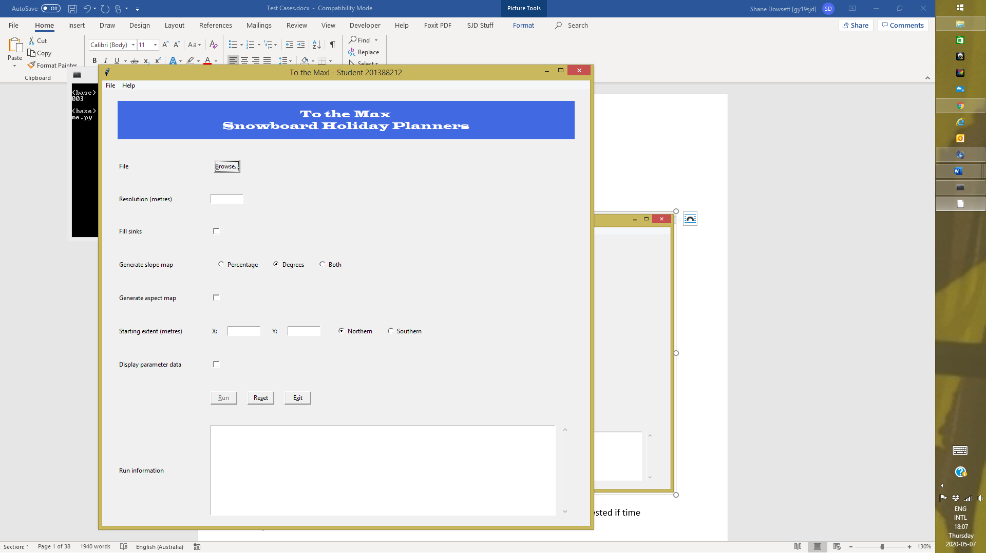

|  |  |  |  |
| --- | --- | --- | --- |
| **Test**  **#** | **Description** | **Comments / Expected Results** | **Pass /**  **Fail** |
| **1** | **Navigation** |  |  |
| 1.1 | Start app from command line running tothemaxhome.py | Loads GUI front end. | Pass |
| 1.2 | Start app from command line running tothemaxmain.py | Runs app without GUI front-end. | Pass |
| 1.3 | Exit app using Alt-x | Program exits. | Pass |
| 1.4 | Exit app using File > Exit | Program exits. | Pass |
| 1.5 | Exit app using Exit button | Program exits. | Pass |
| 1.6 | Help > Inputs | Returns tothemaxmain.py -h information.  Pop-up window appears. | Pass |
| 1.7 | Help > About | Pop-up window appears. | Pass |
| 1.8 | Reset fields using Alt-s | URL label cleared.  All Entry fields cleared.  Generate slope map set to Degrees.  Starting extent set to Northern Hemisphere.  All Check Buttons unchecked.  Run Information cleared. | Pass |
| 1.9 | Reset fields using File > Reset | Same as test 1.8. | Pass |
| 1.10 | Reset fields using Reset button | Same as test 1.8. | Pass |
| 1.11 | Run app using Alt-r | Matplotlib figure appears (if no errors).  Contains any confirmation of parameter settings if Display parameter data check button checked at the time.  Any errors displayed in Run Information. | Pass |
| 1.12 | Run app using File > Run… | Same as test 1.11. | Pass |
| 1.13 | Run app using Run button | Same as test 1.11. | Pass |
|  |  |  |  |
| **2** | **Front-end fields (initial display)** |  |  |
| 2.1 | URL label, entry fields, text box | All empty. | Pass |
| 2.2 | Radio Buttons set (Generate slope map) | Set to “Degrees” option. | Pass |
| 2.3 | Radio Buttons set (Hemisphere) | Set to “Northern” option. | Pass |
| 2.4 | Check buttons | All unchecked. | Pass |
| 2.5 | Button (Run…) | Disabled. | Pass |
| 2.6 | Menu bar (File > Run…) | Disabled. | Pass |
| 2.7 | Cursor focus position | Located on Browse… button. | Pass |
|  |  |  |  |
| **3** | **Front-end fields (after any run)** |  |  |
| 3.1 | URL label, entry fields, radio Buttons, check buttons | All unchanged. | Pass |
| 3.2 | Text box | Contains any confirmation of parameter settings if Display parameter data check button checked at the time.  Any error messages. | Pass |
| 3.3 | Cursor focus position | Located on Run… button. | Pass |
|  |  |  |  |

|  |  |  |  |
| --- | --- | --- | --- |
| **4** | **Front-end fields – File** |  |  |
| 4.1 | Empty (initial display) | Run button and File > Run… is disabled to prevent running without data input. | Pass |
| 4.2 | Populated after returning from Browse… operation (file selected) | URL parsed into tothemaxmain.py. | Pass |
| 4.3 | Cleared after returning from Browse… operation (no file selected) | Run button and File > Run… reverts to being disabled. | Pass |
| 4.4 | Cleared after the Reset or File > Reset operations | Run button and File > Run… reverts to being disabled. | Pass |
|  |  |  |  |
| **5** | **Front-end fields – Resolution (metres)** |  |  |
| 5.1 | Empty | No argument parsed.  Defaults to 50 (hard coded). | Pass |
| 5.2 | Contains at least 1 Alphanumeric character | Run terminates.  Error displayed in Run Information. | Pass |
| 5.3 | Contains as least 1 space character | Run terminates.  Error displayed in Run Information. | Pass |
| 5.4 | Contains zero | Run terminates.  Error displayed in Run Information. | Pass |
| 5.5 | Contains a positive integer | Value parsed into tothemaxmain.py and overrides default.  Difference on the x axis range of each subplot / number of cells in rows = this value.  Difference on the y axis range of each subplot / number of cells in rows = this value. | Pass |
| 5.6 | Contains a negative integer | Run terminates.  Error displayed in Run Information. | Pass |
| 5.7 | Contains a floating-point number | Run terminates.  Error displayed in Run Information. | Pass |
|  |  |  |  |
| **6** | **Front-end fields – Fill Sinks** |  |  |
| 6.1 | Unchecked | No argument parsed.  Defaults to N (hard coded).  Slope and aspect maps potentially displayed with some NoData cells. | Pass |
| 6.2 | Checked | Y parsed into tothemaxmain.py and overrides default.  Majority of non-edge cells with NoData will be resolved.  Edge cells with NoData remain unresolved and displayed as colourless. | Pass |
|  |  |  |  |

|  |  |  |  |
| --- | --- | --- | --- |
| 7 | **Front-end fields – Generate slope map** |  |  |
| 7.1 | Percentage | P parsed into tothemaxmain.py and overrides default.  Slope map (Percentage) displayed in Matplotlib figure at subplot position row:2 column:1. | Pass |
| 7.2 | Degrees | D parsed into tothemaxmain.py (same as default).  Slope map (Degrees) displayed in Matplotlib figure at subplot position row:2 column:1. | Pass |
| 7.3 | Both | B parsed into tothemaxmain.py and overrides default.  Slope map (Degrees) displayed in Matplotlib figure at subplot position row:2 column:1.  Slope map (Percentage) displayed in Matplotlib figure at subplot position row:2 column:2. | Pass |
| 7.4 | Mutually exclusive | Yes. | Pass |
|  |  |  |  |
| 8 | **Front-end fields – Generate aspect map** |  |  |
| 8.1 | Unchecked | No argument parsed.  Defaults to N (hard coded).  No Matplotlib figure at subplot position row:1 column:2. | Pass |
| 8.2 | Checked | Y parsed into tothemaxmain.py and overrides default.  Aspect map displayed in Matplotlib figure at subplot position row:1 column:2. | Pass |
|  |  |  |  |
| 9 | **Front-end fields – Starting Extent (metres) X** |  |  |
| 9.1 | Empty | No argument parsed.  Defaults to 0 (hard coded).  Starting x axis value on all subplots = 0.  Ending x axis value on all subplots = number of cells in rows x Resolution. | Pass |
| 9.2 | Contains at least 1 Alphanumeric character | Run terminates.  Error displayed in Run Information. | Pass |
| 9.3 | Contains as least 1 space character | Run terminates.  Error displayed in Run Information. | Pass |
| 9.4 | Contains zero, positive or negative integer | Value parsed into tothemaxmain.py and overrides default.  Starting x axis value on all subplots = this value.  Ending x axis value on all subplots = this value + (number of cells in rows x Resolution) | Pass |
| 9.5 | Contains a floating-point number | Run terminates.  Error displayed in Run Information. | Pass |
|  |  |  |  |

|  |  |  |  |
| --- | --- | --- | --- |
| 10 | **Front-end fields – Starting Extent (metres) Y** |  |  |
| 10.1 | Empty | No argument parsed.  Defaults to 0 (hard coded).  Starting y axis value on all subplots = 0.  Ending y axis value on all subplots = number of rows x Resolution. | Pass |
| 10.2 | Contains at least 1 Alphanumeric character | Run terminates.  Error displayed in Run Information. | Pass |
| 10.3 | Contains as least 1 space character | Run terminates.  Error displayed in Run Information. | Pass |
| 10.4 | Contains zero, positive or negative integer | Value parsed into tothemaxmain.py and overrides default.  Starting y axis value on all subplots = this value.  If Northern Hemisphere selected: Ending y axis value on all subplots = this value + (number of cells in rows x Resolution)  If Southern Hemisphere selected: Ending y axis value on all subplots = this value - (number of cells in rows x Resolution) | Pass |
| 10.5 | Contains a floating-point number | Run terminates.  Error displayed in Run Information. | Pass |
|  |  |  |  |
| 11 | **Front-end fields – Hemisphere** |  |  |
| 11.1 | Northern | N parsed into tothemaxmain.py and overrides default.  Starting / ending y axis values displayed on all subplots is ascending. | Pass |
| 11.2 | Southern | S parsed into tothemaxmain.py and overrides default.  Starting / ending y axis values displayed on all subplots is descending. | Pass |
| 11.3 | Mutually exclusive | Yes. | Pass |
|  |  |  |  |
| **12** | **Front-end fields – Display parameter data** |  |  |
| 12.1 | Unchecked | No parameter information displayed. | Pass |
| 12.2 | Checked | Y parsed into tothemaxmain.py and overrides default.  Summary of run parameters passed returned. | Pass |
|  |  |  |  |
| **13** | **Input raster file (snow.slope)** |  |  |
| 13.1 | No. of cell values in each row not consistent | Run terminates.  Error displayed in Run Information. | Pass |
| 13.2 | Cell value not numeric | Run terminates.  Error displayed in Run Information. | Pass |
|  |  |  |  |

|  |  |  |  |
| --- | --- | --- | --- |
| **14** | **Input raster file (georeferenced)** |  |  |
| 14.1 | With ncols row | Used to validate no. of data cells input. | Pass |
| 14.2 | With nrows row | Used to validate no. of data cells input. | Pass |
| 14.3 | With xllcorner row | Used to populate Starting extent (X). | Pass |
| 14.4 | With xllcenter row | Used to populate Starting extent (X). | Pass |
| 14.5 | With yllcorner row | Used to populate Starting extent (Y). | Pass |
| 14.6 | With yllcenter row | Used to populate Starting extent (Y). | Pass |
| 14.7 | With cellsize row | Used to populate Resolution.  Used to calculated Starting extent (X) when xllcenter input instead of xllcorner.  Used to calculated Starting extent (Y) when yllcenter input instead of yllcorner. | Pass |
| 14.8 | With nodata_value row | Used to identify NoData input data cells. | Pass |
|  |  |  |  |
| **15** | **General running of app without errors** |  |  |
| 15.1 | Georeferenced input file | Resolution and Starting extents (x & y) prepopulated.  2 to 4 maps generated. | Pass |
| 15.2 | Non-georeferenced input file | No front-end fields prepopulated.  2 to 4 maps generated. | Pass |
| 15.3 | Elevation map | Generated for every run. | Pass |
| 15.4 | Slope map as a Percentage | Generated if selected via front-end. | Pass |
| 15.5 | Slope map in Degrees | Generated if selected via front-end. | Pass |
| 15.6 | Aspect map | Generated if selected via front-end. | Pass |
| 15.7 | At least one downhill cell in a neighbourhood | No affect on number of maps produced or data cell values in slope and aspect maps. | Pass |
| 15.8 | No downhill cells in a neighbourhood – sinks not filled | Affected edge cells displayed in slope and aspect map with NoData (NaN) – regardless of whether Fill sinks is selected or not. | Pass |
| 15.9 | No downhill cells in a neighbourhood – sinks filled | Resolved with taking the lowest elevation of the eight neighbours. | Pass |
| 15.10 | Map located entirely in Northern hemisphere | Starting and ending y axis labels both display North and are ascending. | Pass |
| 15.11 | Map located entirely in Southern hemisphere | Starting and ending y axis labels both display South and are descending. | Pass |
| 15.12 | Starting and ending extents (y axis) located opposite hemispheres | Starting y axis label displays South.  Ending y axis label displays North. | Pass |
| 15.13 | Input file contains a NoData cell. | Cell remains as NoData throughout.  Corresponding slope map cell contains NoData (NaN).  Corresponding aspect map cell contains NoData (NaN). | Pass |

|  |  |  |  |
| --- | --- | --- | --- |
| **16** | **Output files** |  |  |
| 16.1 | snow_slope_map_perc.txt  (Slope map data as a percentage) | File not georeferenced.  Format and layout matches input file.  File overwritten for each run.  Contains same number of rows and cells as in input file.  Each data cell is in float format with precision to 1 decimal place.  NoData is represented as NaN. | Pass |
| 16.2 | snow_slope_map_deg.txt  (Slope map data in degrees) | File not georeferenced.  Format and layout matches input file.  File overwritten for each run.  Contains same number of rows and cells as in input file.  Each data cell is in float format with precision to 1 decimal place.  NoData is represented as NaN. | Pass |
| 16.3 | snow_aspect_map.txt  (Aspect map data) | File not georeferenced.  Format and layout matches input file.  File overwritten for each run.  Contains same number of rows and cells as in input file.  Each data cell is in integer format.  NoData is represented as NaN. | Pass |

**GEOG5003M – Assignment 2 Testing Evidence**

**Test Case 1.6 – Help information.**

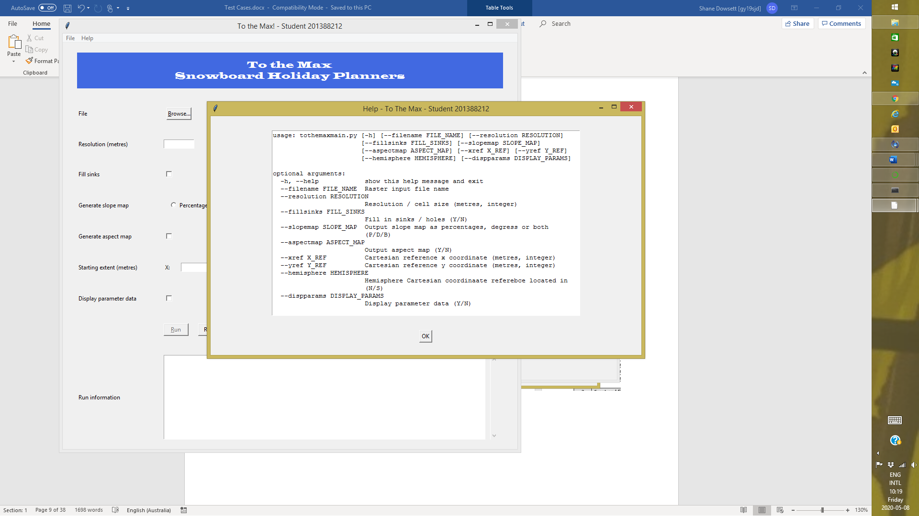

**Test Case 1.7 – About information.**

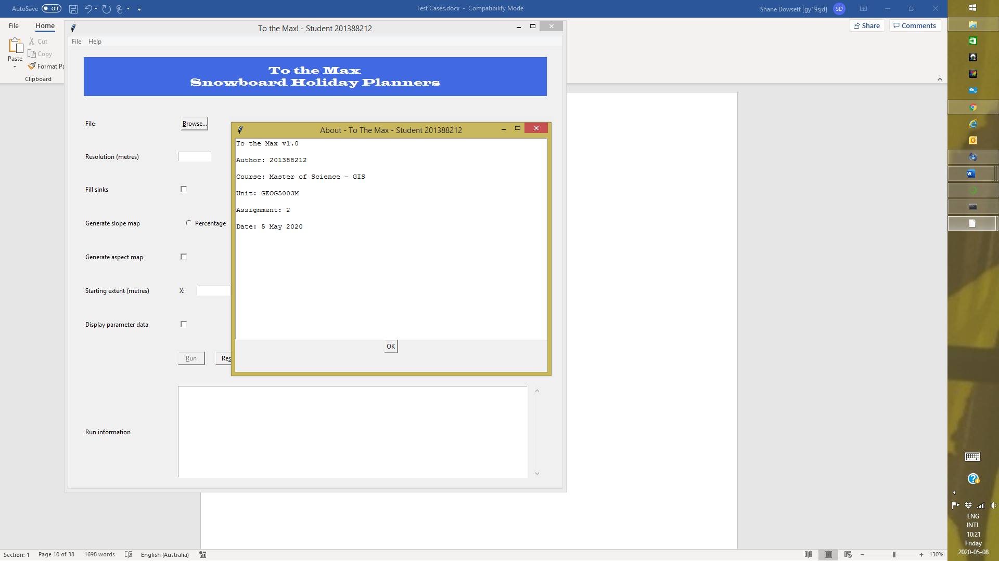

**Test Case 13.1 – Corrupt input file (1).**

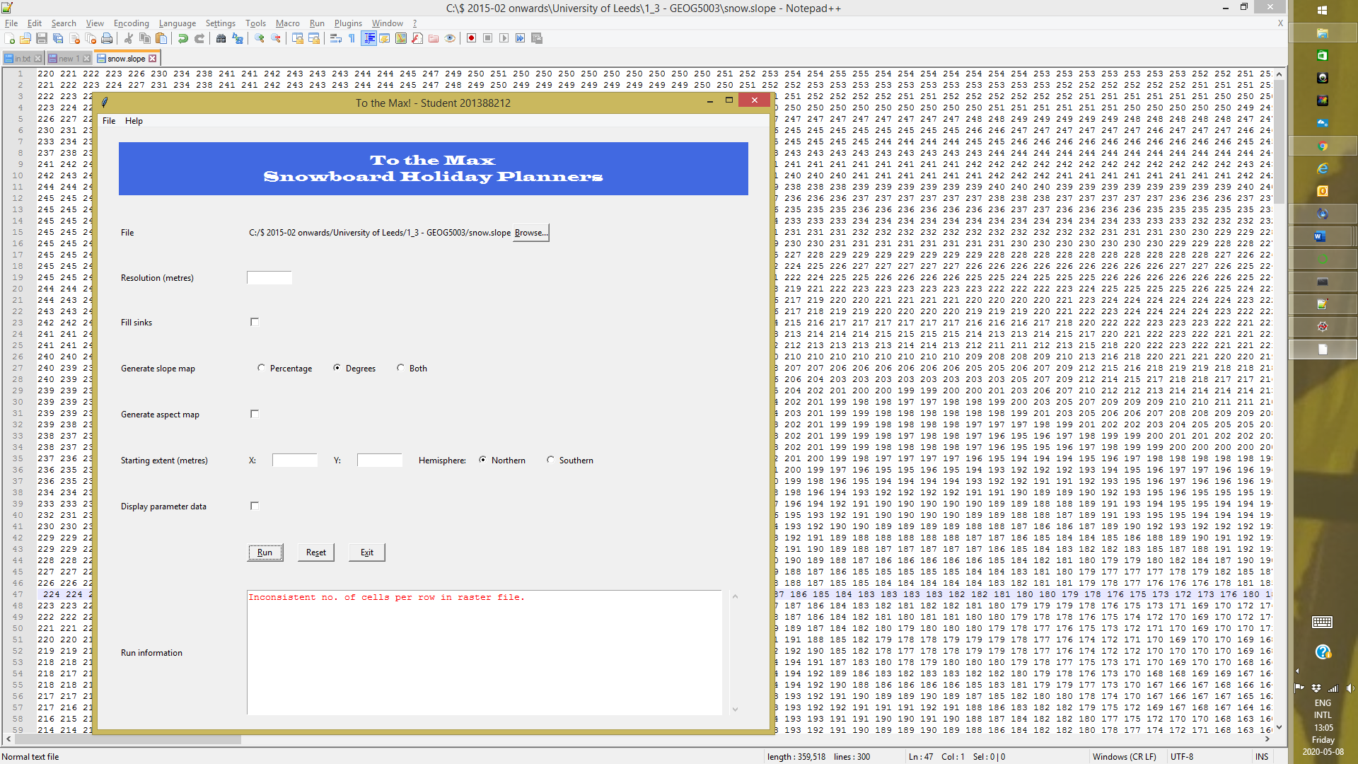

**Test Case 13.2 – Corrupt input file (2).**

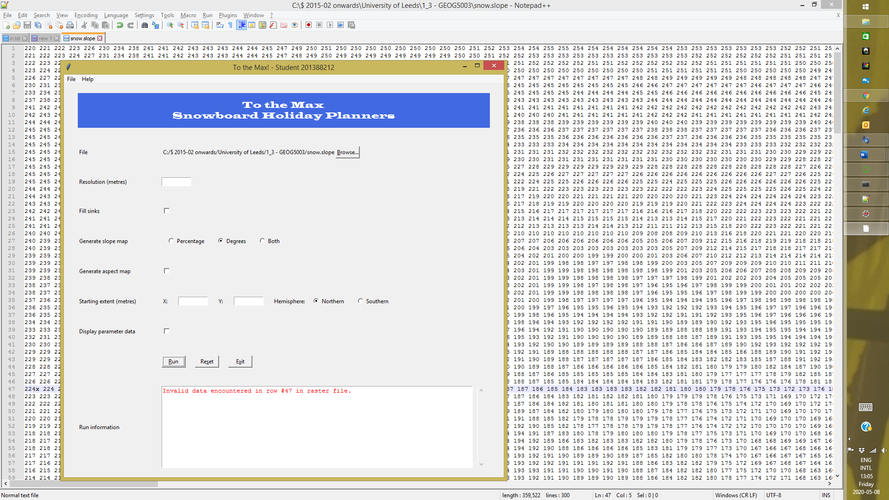

**Test Cases 5.2, 9.2, 10.2 – Invalid parameter data.**

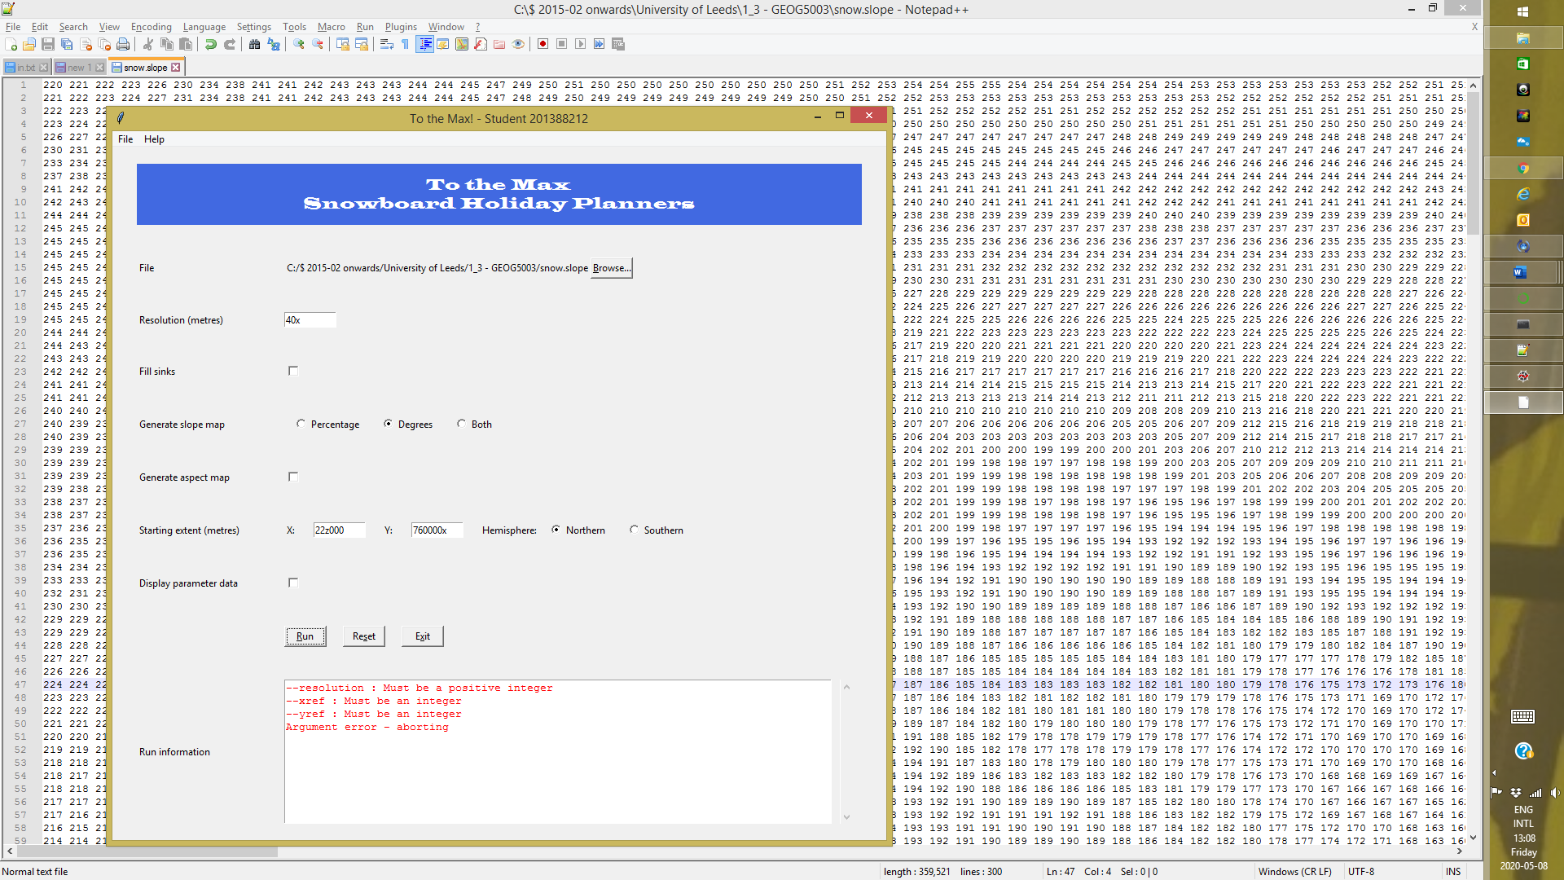

**Test Cases 5.1, 6.1, 7.2, 8.1, 9.1, 10.1, 11.1 – Standard run with no overrides.**

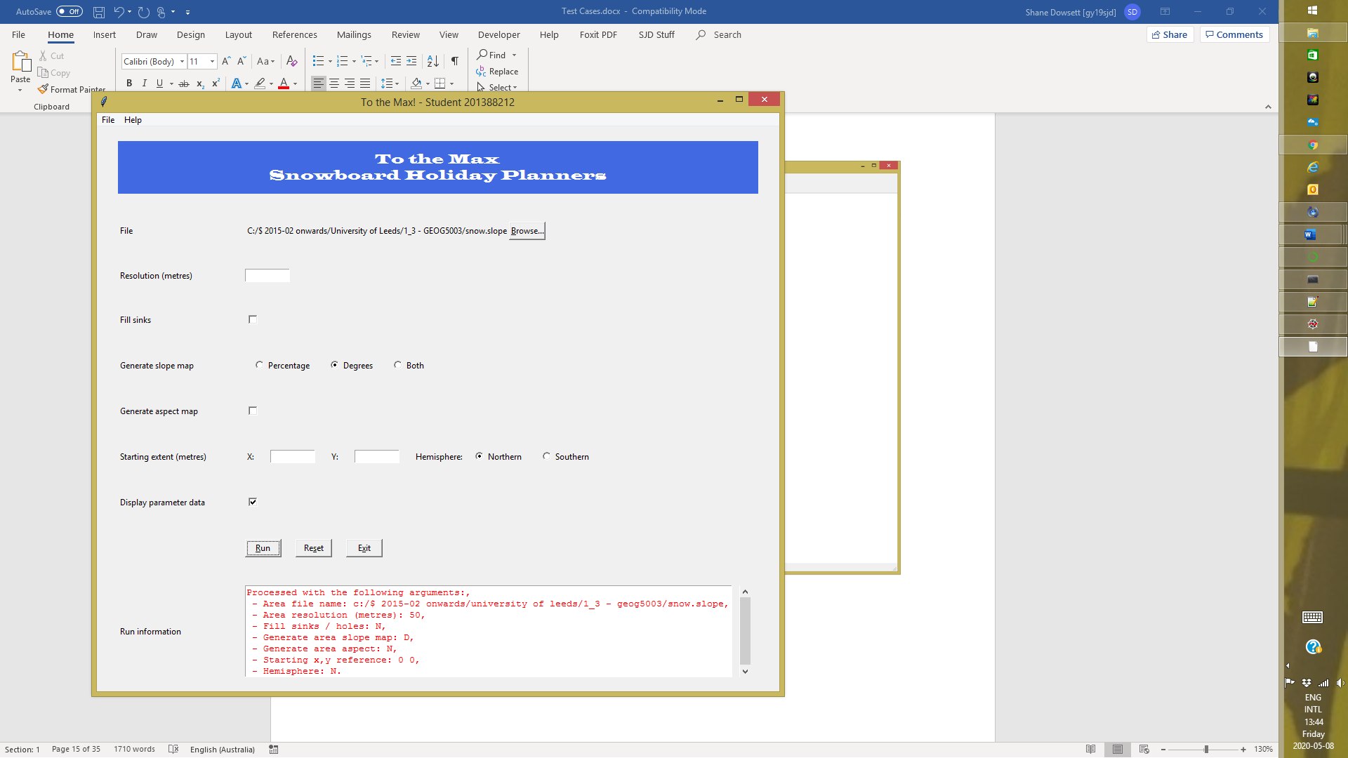

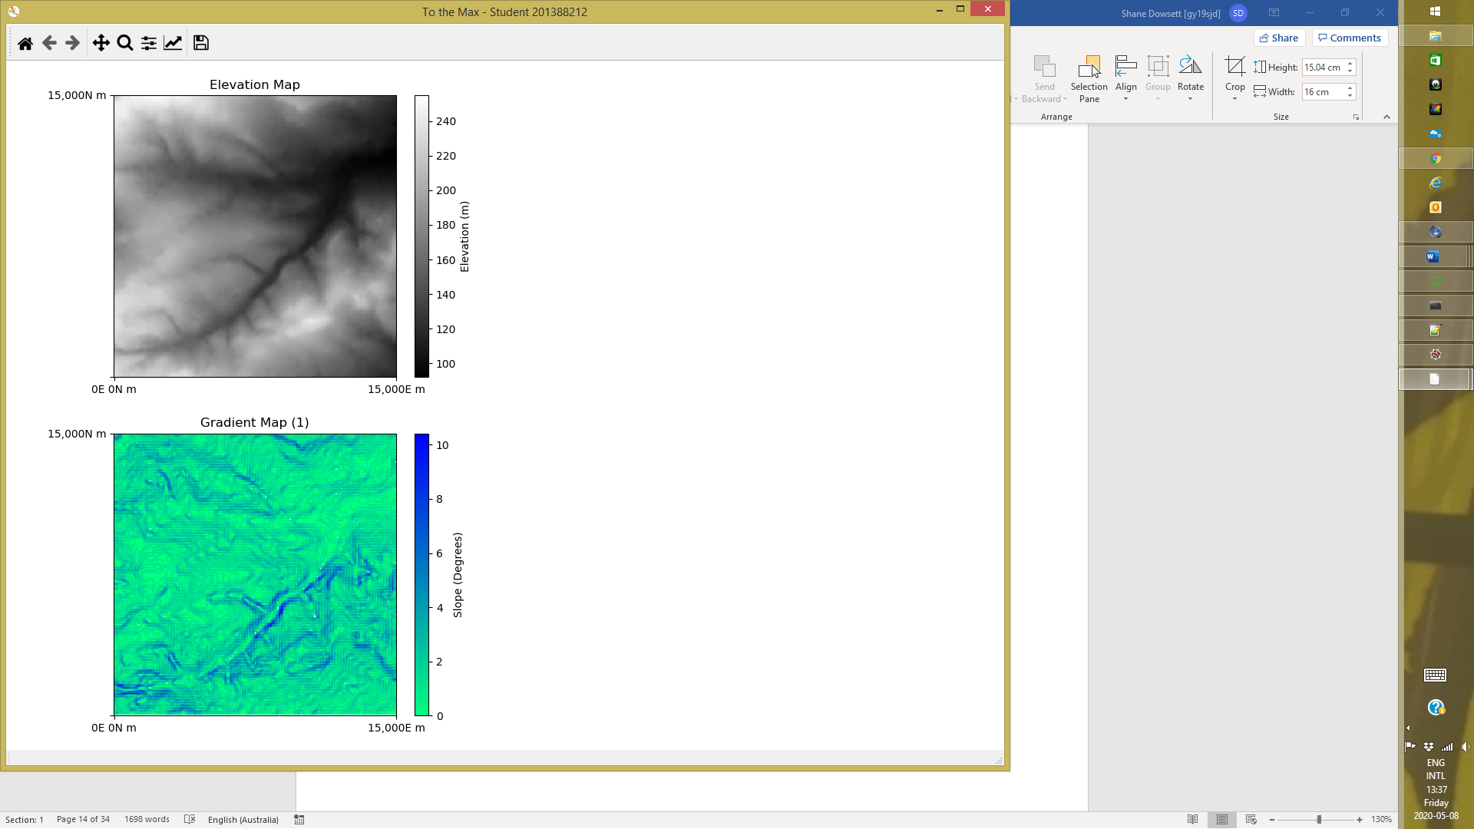

**Test Cases 10.4, 11.2, 15.11 – Southern hemisphere labels.**

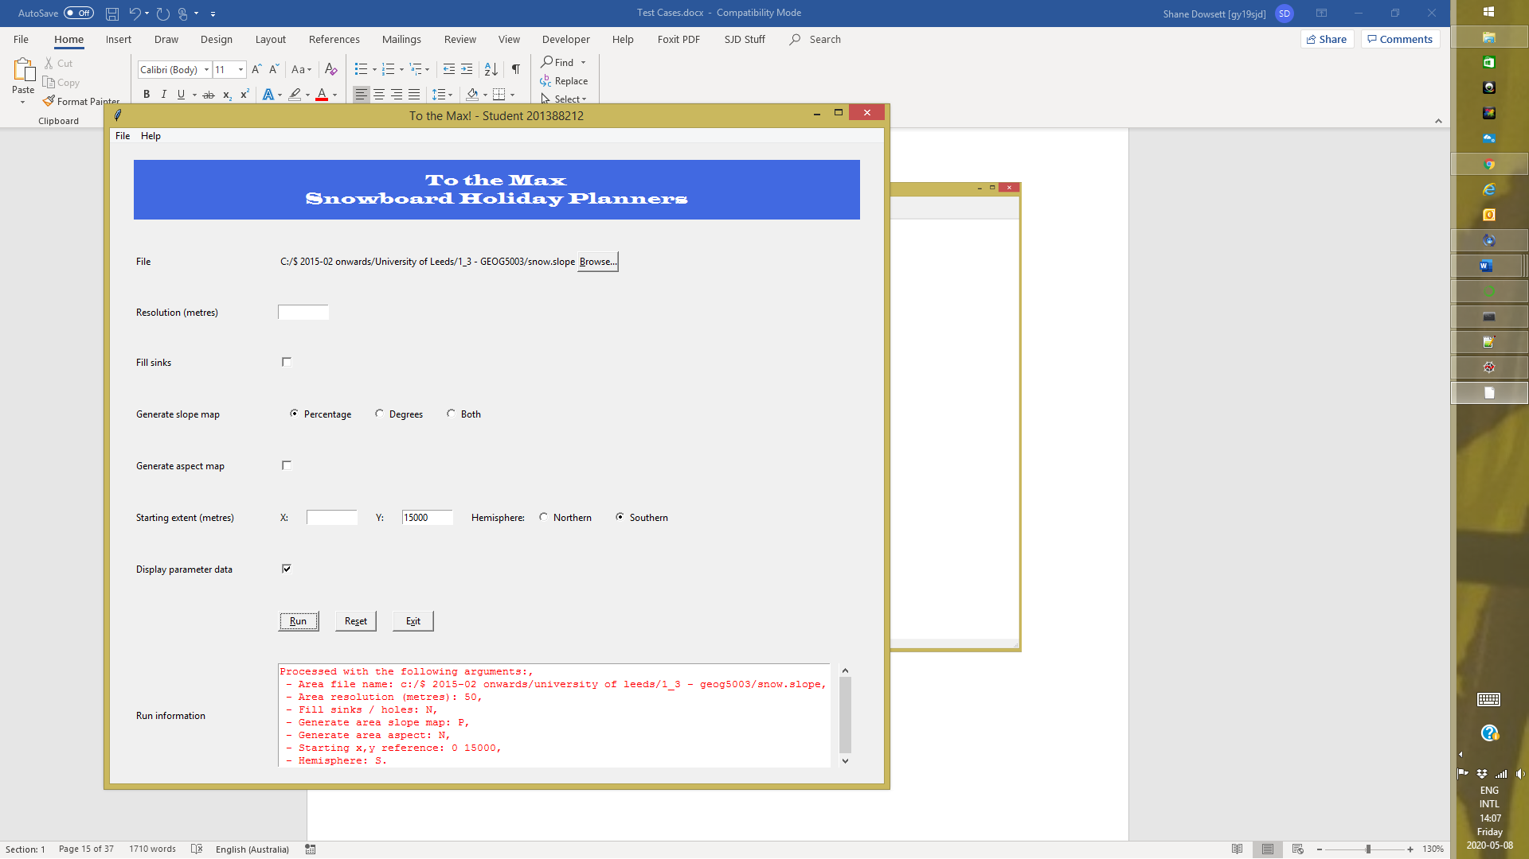

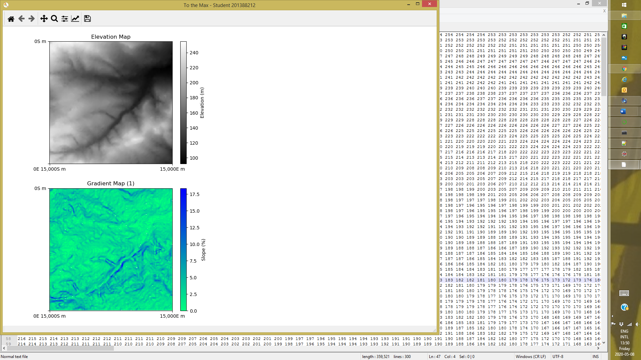

**Test Cases 15.12 – Y axis label either side of equator.**

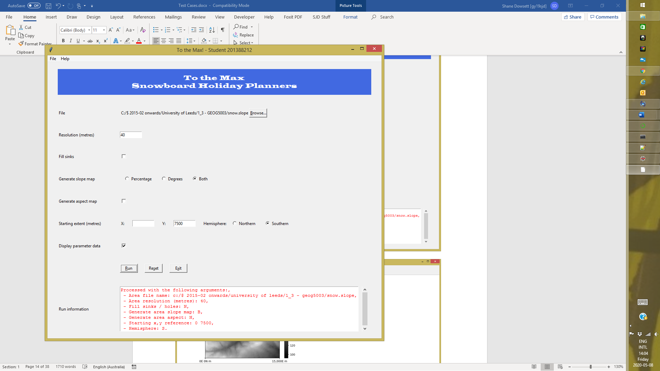

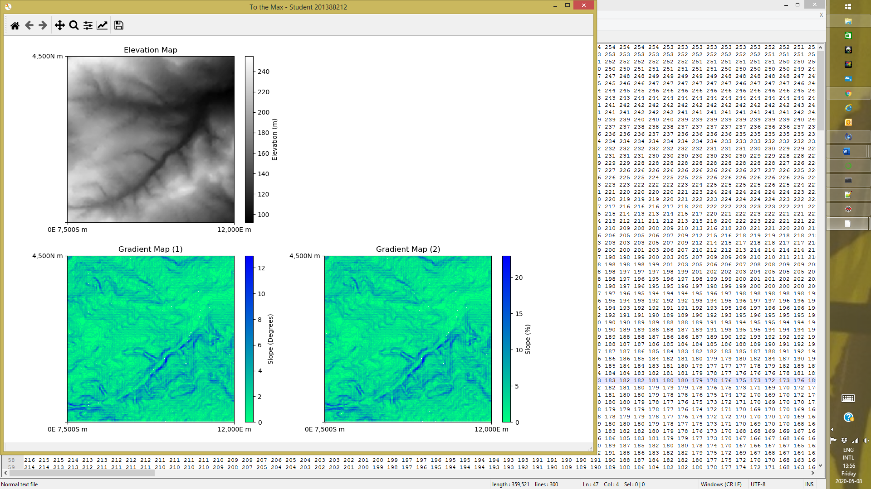

**Test Cases 5.5, 6.2, 7.3, 8.2, 9.4, 10.4, 11.1, 12.2, 16.1-3 – Standard run with full set of overrides.**

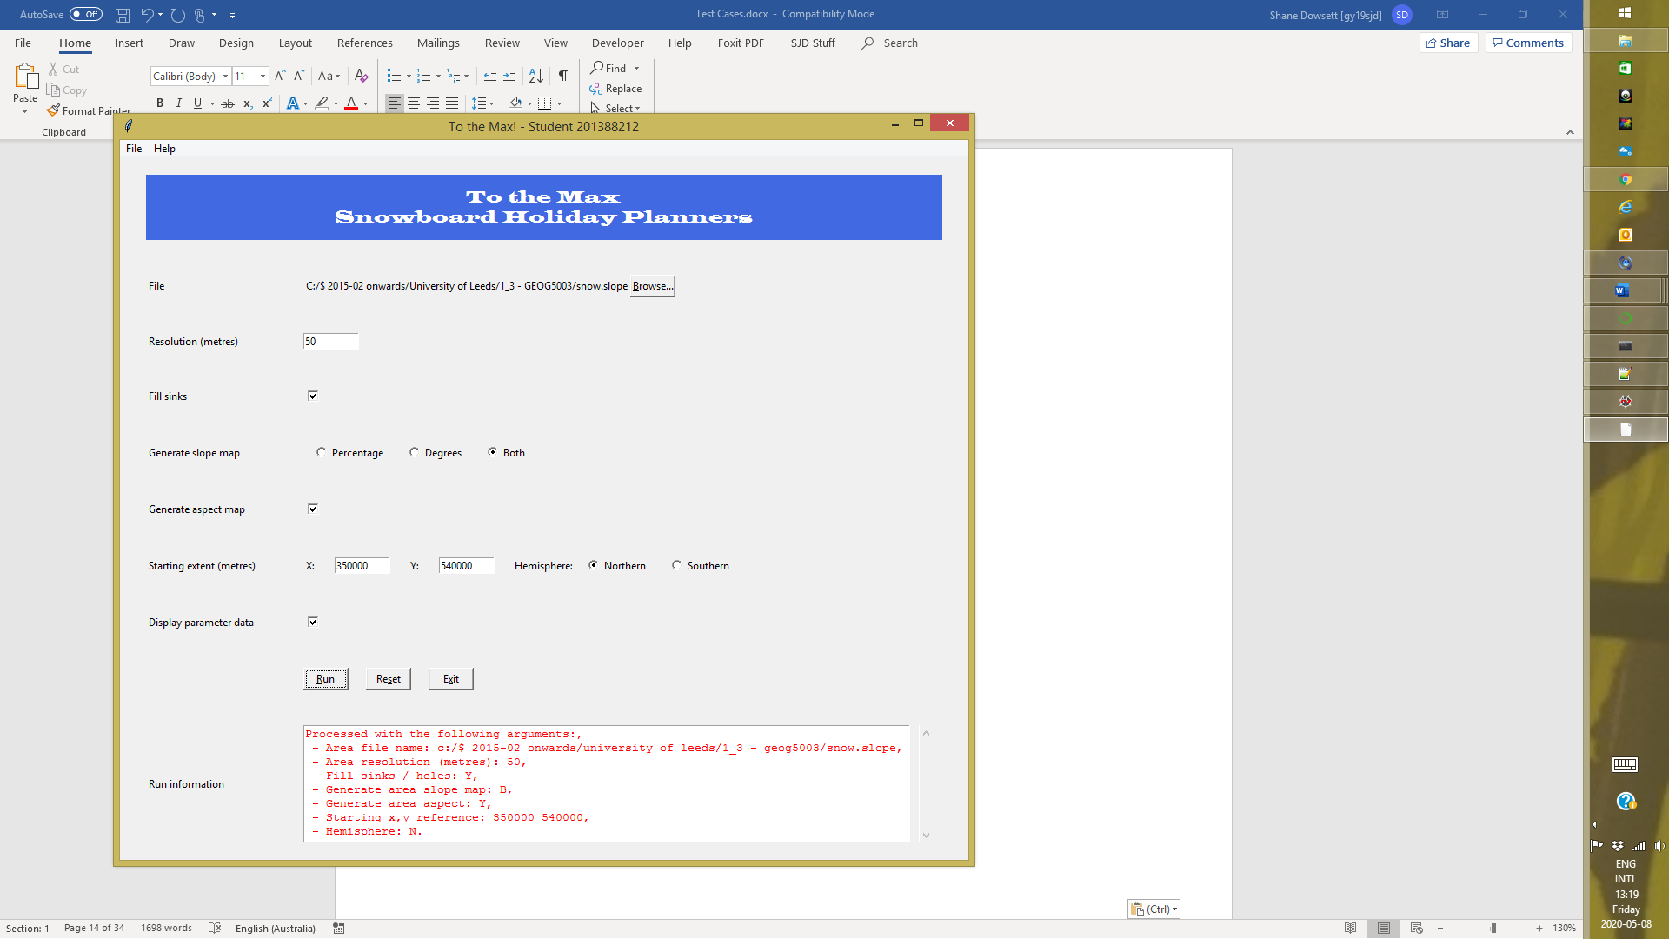

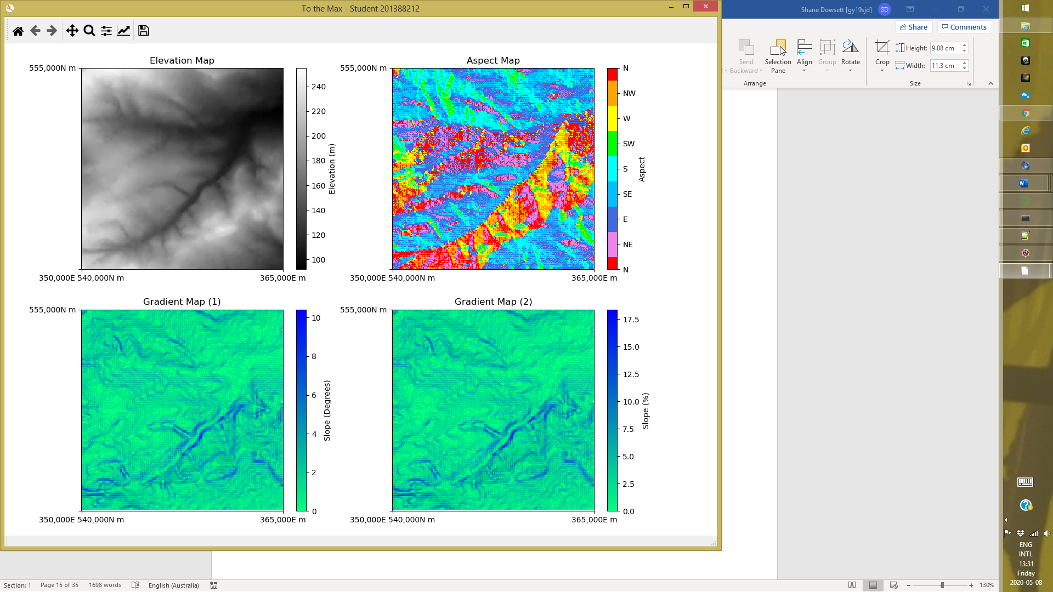

**Test Cases 14.1-3, 14.5, 14.7, 15.1, 15.3-7. 15.9-10, 16.1-3 – Georeferenced input file.**

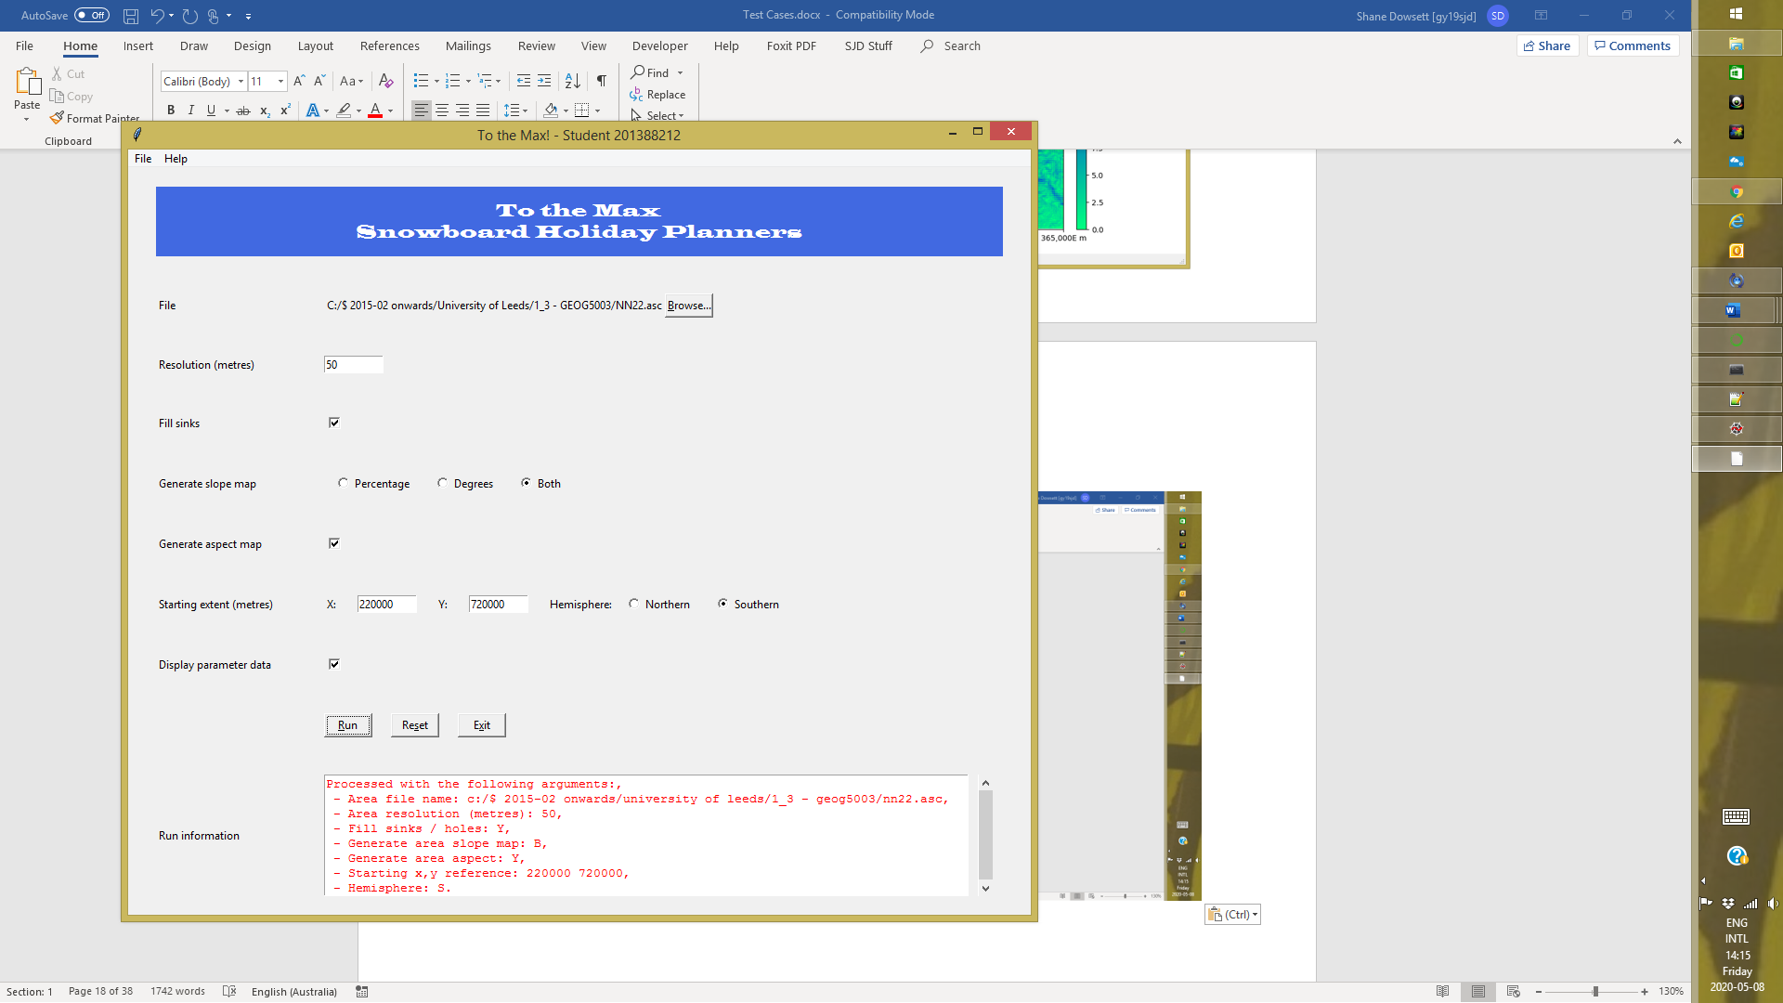

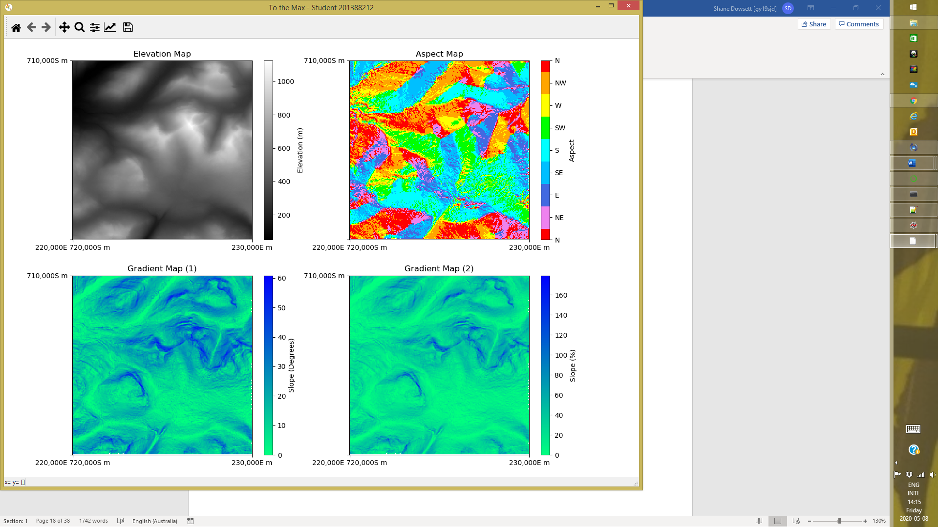**Test Cases 6.1-2, 15.8-9 – Sink handling**

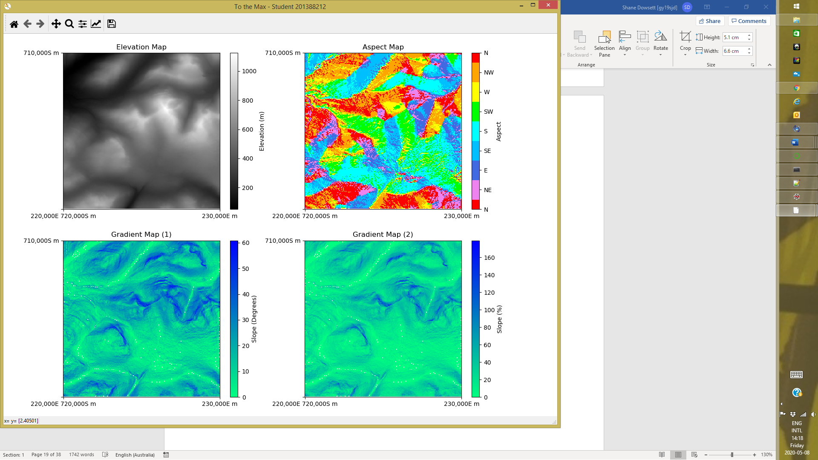



**Test Cases 16.1-3 – Output file.**

Refer to following output files:

* Related to snow.slope
  + snow_slope_map_perc_1.txt
  + snow_slope_map_deg_1.txt
  + snow_aspect_map_1.txt
* Related to nn22.asc (georeferenced)
  + snow_slope_map_perc_2.txt
  + snow_slope_map_deg_2.txt
  + snow_aspect_map_2.txt